✅ 3. WHAT YOU ACTUALLY NEED (REAL SETUP)

🔥 Best setup for SafeBite:

Option A (Recommended — professional)
- Google Workspace
or
- Microsoft 365
Cost: ~£5–£10/month per email

You get:
- support@safebite.co.uk
- admin@safebite.co.uk
- legal@safebite.co.uk
- Full inbox + sending
- High deliverability (emails won’t go to spam)
🧱 4. EMAIL STRUCTURE YOU SHOULD CREATE (LOCK THIS IN)
For SafeBite:
- support@safebite.co.uk → users
- hello@safebite.co.uk → general
- partnerships@safebite.co.uk → supermarkets
- legal@safebite.co.uk → compliance
- noreply@safebite.co.uk → app emails

✉️ EMAIL BRAND TEMPLATE (YOU SHOULD USE)
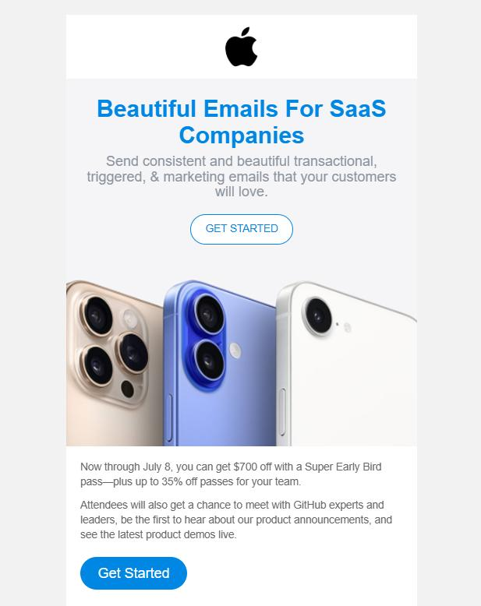
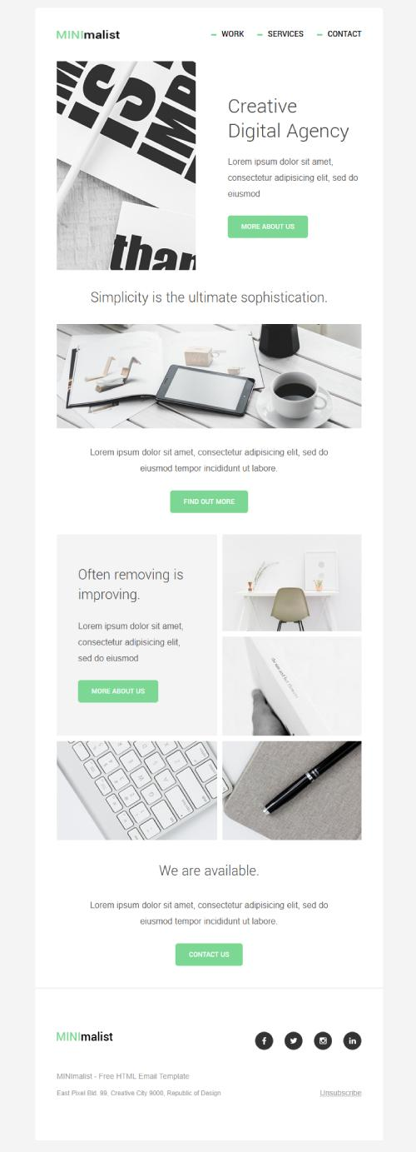
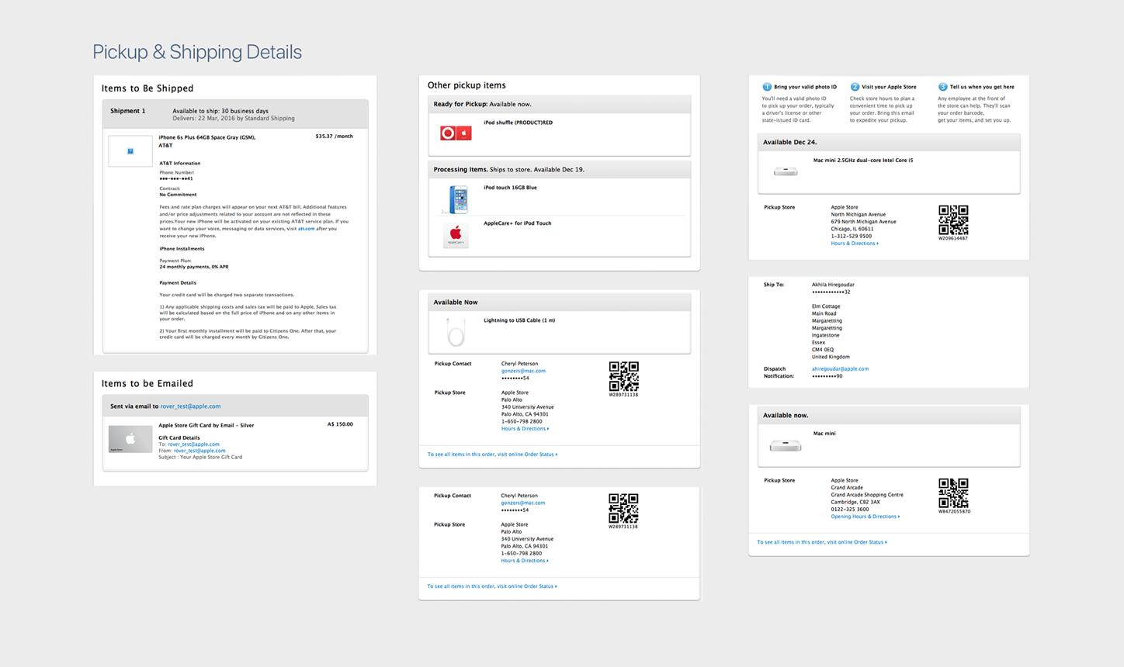
6

Your SafeBite email style:

Header:
- Logo (left)
- Clean white background

Body:
- Large title
- Clear message
- One action button

Footer:
- Company name
- Contact email
- Legal links

⚙️ 6. WHAT SENDS EMAILS FROM YOUR APP
Later (important for your build):
You’ll connect your backend to:
- SendGrid
or
- Resend
These handle:
- Verification emails
- Alerts
- Notifications

🔐 7. IMPORTANT (MOST PEOPLE MISS THIS)
To avoid spam / blocking you MUST set:
- SPF record
- DKIM
- DMARC
These are configured via Cloudflare DNS.
👉 Without this:
- Emails go to spam
- Or get blocked completely

